DAY 82 DIY SOLUTION

1.. Load the given dataset into a tableau workbook

2. Change the “quarter end date” column’s the data type to date

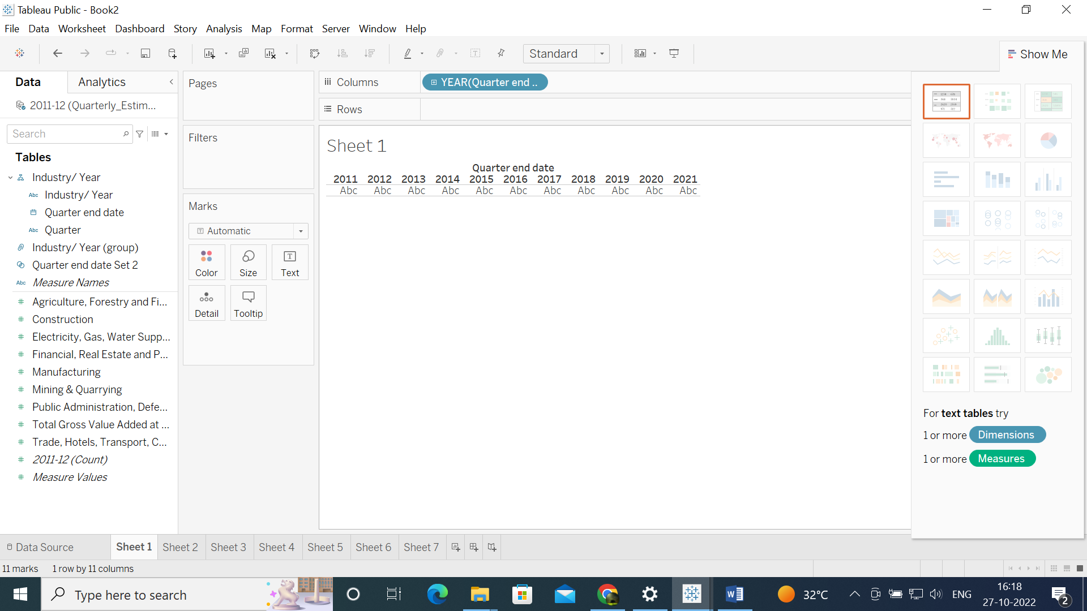

3. Make a hierarchy of “year”, “quarter”, and “quarter end date” in the given order, and using a bar chart observe “Public Administration, Defense, and Other Services”

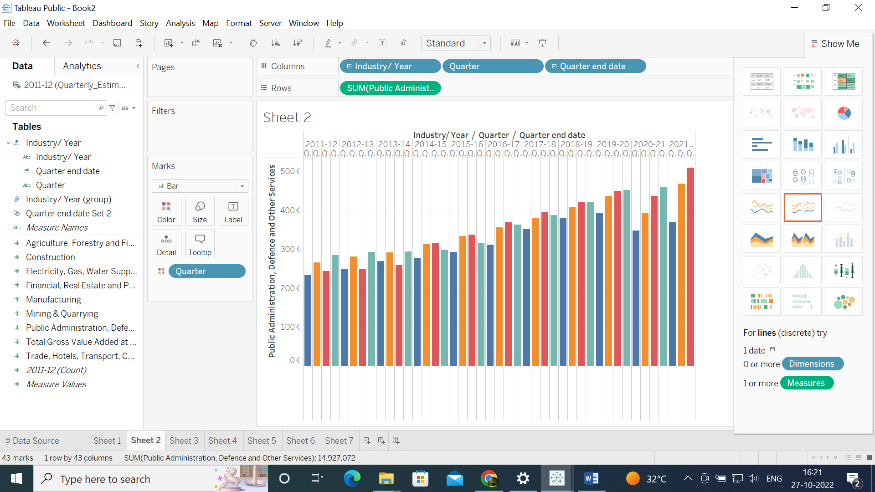

4. Print multilevel bar chart for “manufacturing”, “construction”, “mining & quarrying”, and use highlighted features on “quarter” and “industry/year”

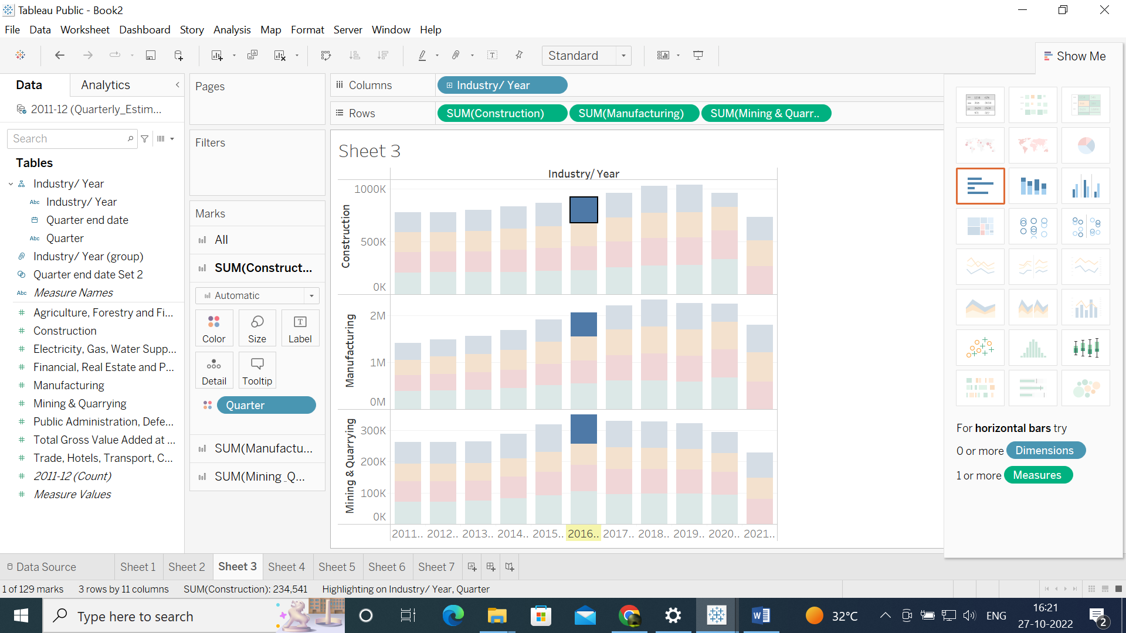

5.Find out in which year mining and quarrying contributed highest to GDP (Do sorting to find the answer visually)

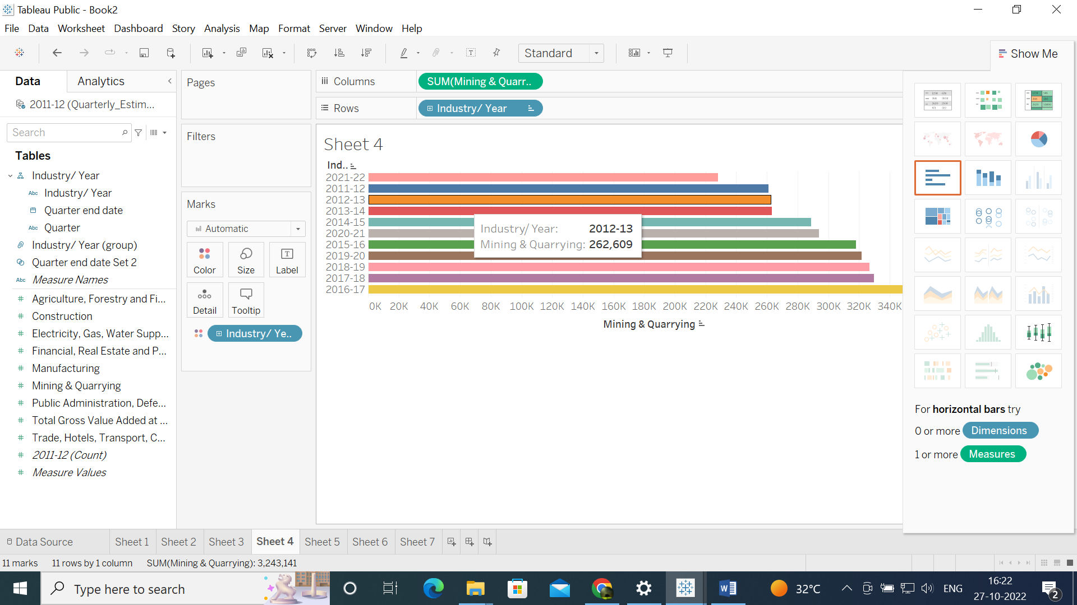

6.Create two groups of the last decade in a 5-year gap on “industry/year” and compare construction activity, (leave 2021-22 out of this because it is not part of the last decade).

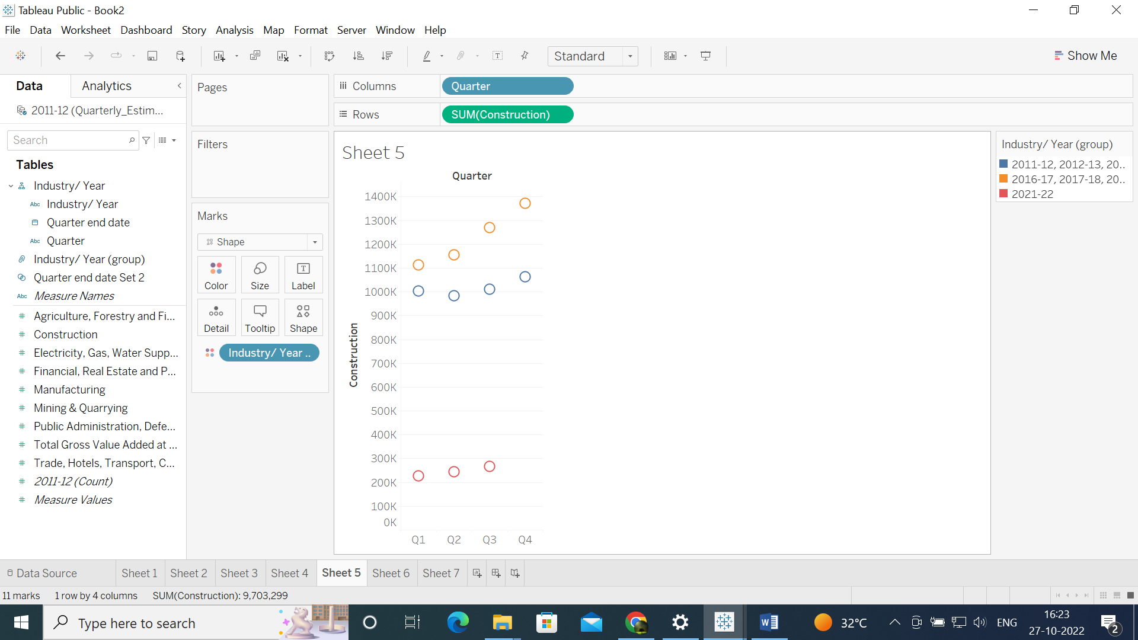

7. Use the filter on quarter and select only q1 and q2 data only then plot horizontal bar chart for “Public Administration, Defense, and Other Services” by different color coding

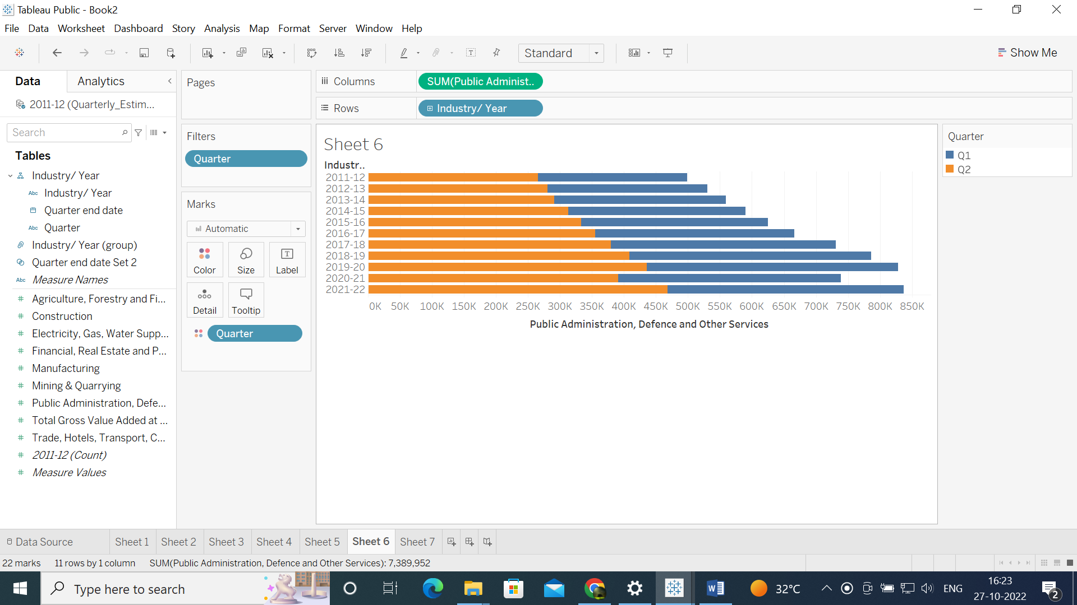

8. Create a set of Q1 as per their end date on the” quarter end date” (select all data from June month) and compare “electricity gas, water supply and other utility” and visualize using a bar plot, and give color to newly created set

